E.M.E.I PROF. JOSÉ MAURO COELHO VERAS

NOME: __________________________________________________________
PROFESSORA:_____________________________________________________
ETAPA II

TODOS CONTRA O CORONAVÍRUS
ETAPA ll
NOME:_______________________________________________________________________
DATA: ____ / ____ / ______
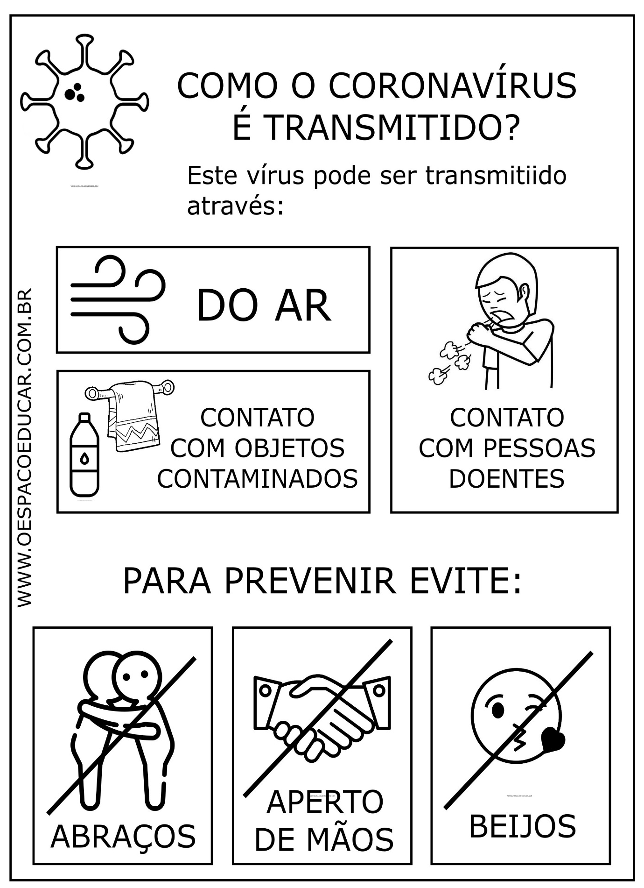
1
NOME:_______________________________________________________________________
DATA: ____ / ____ / ______
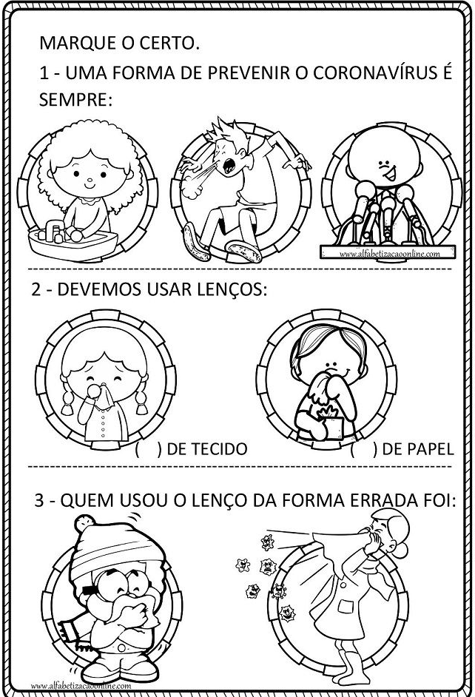
NOME : ______________________________________________________________________
DATA: ____ / ____ / ______
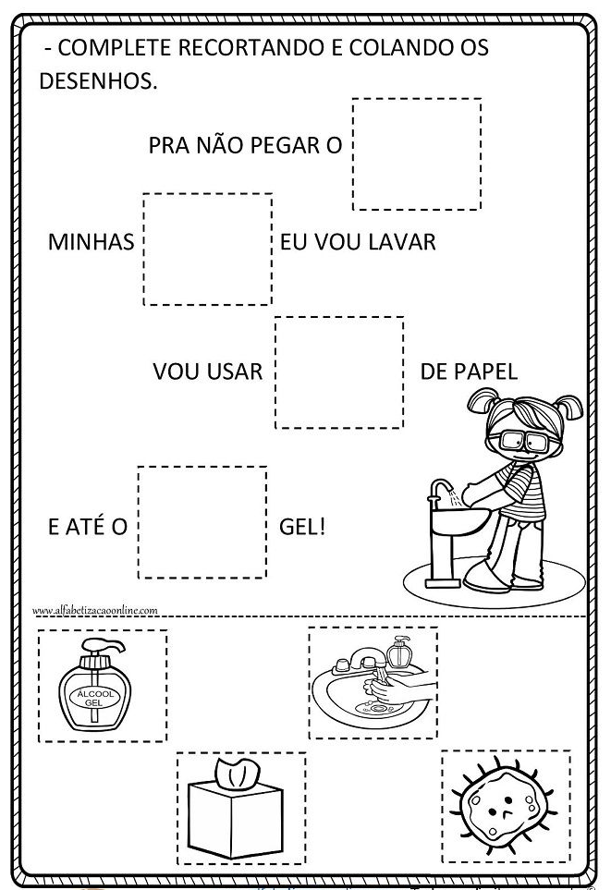
NOME: _____________________________________________________________________________
DATA: ____ / ____ / ______
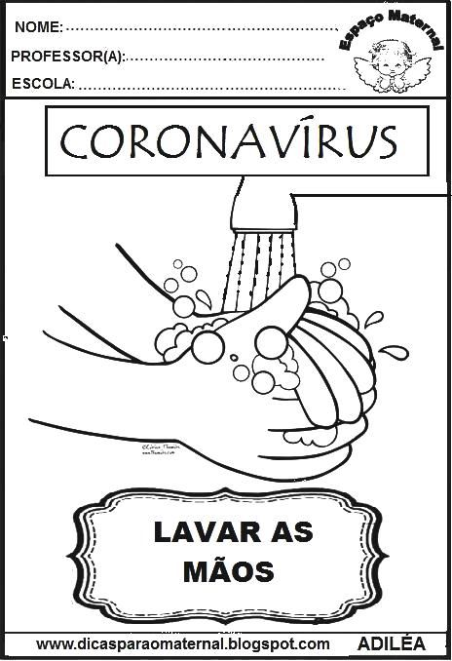
NOME: _______________________________________________________________________
DATA: ____ / ____ / ______
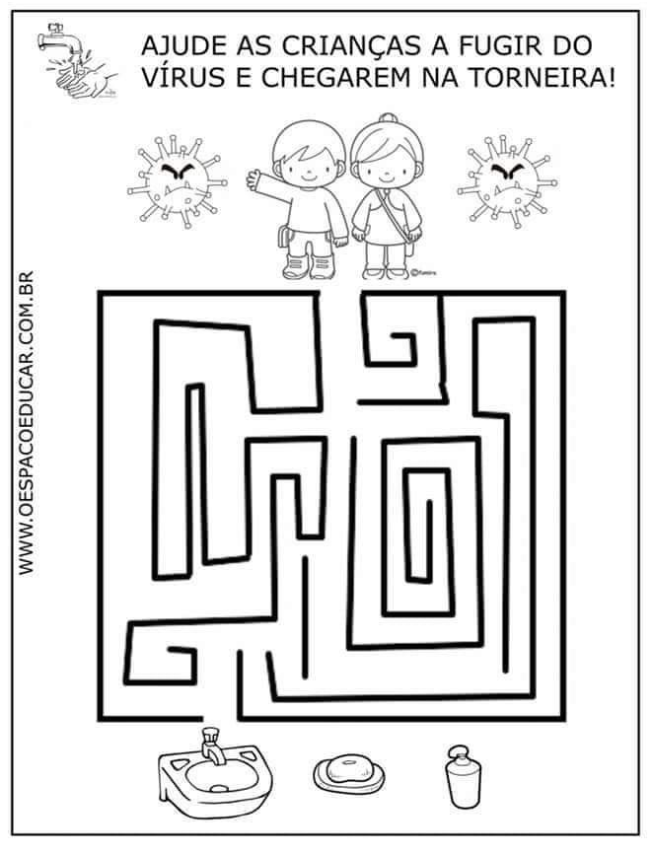
NOME: _______________________________________________________________________
DATA: ____ / ____ / ______
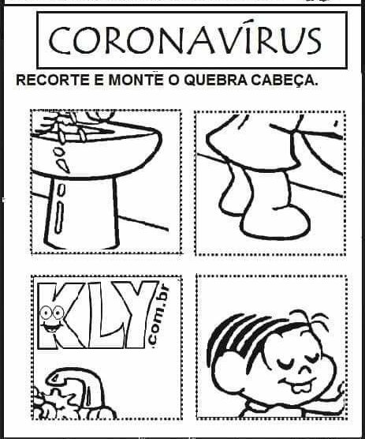
NOME: _______________________________________________________________________
DATA: ____ / ____ / _____

MONTE AQUI SEU QUEBRA CABEÇA

NOME: _______________________________________________________________________
DATA: ____ / ____ / _______
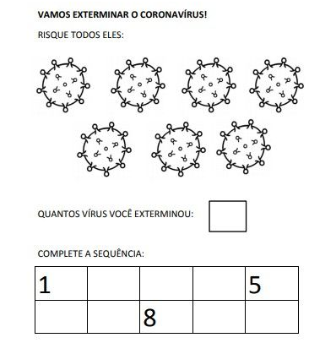
NOME: _______________________________________________________________________
DATA: ____ / ____ / ______
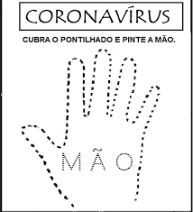
NOME: _______________________________________________________________________
DATA : ____ / _____ / ______
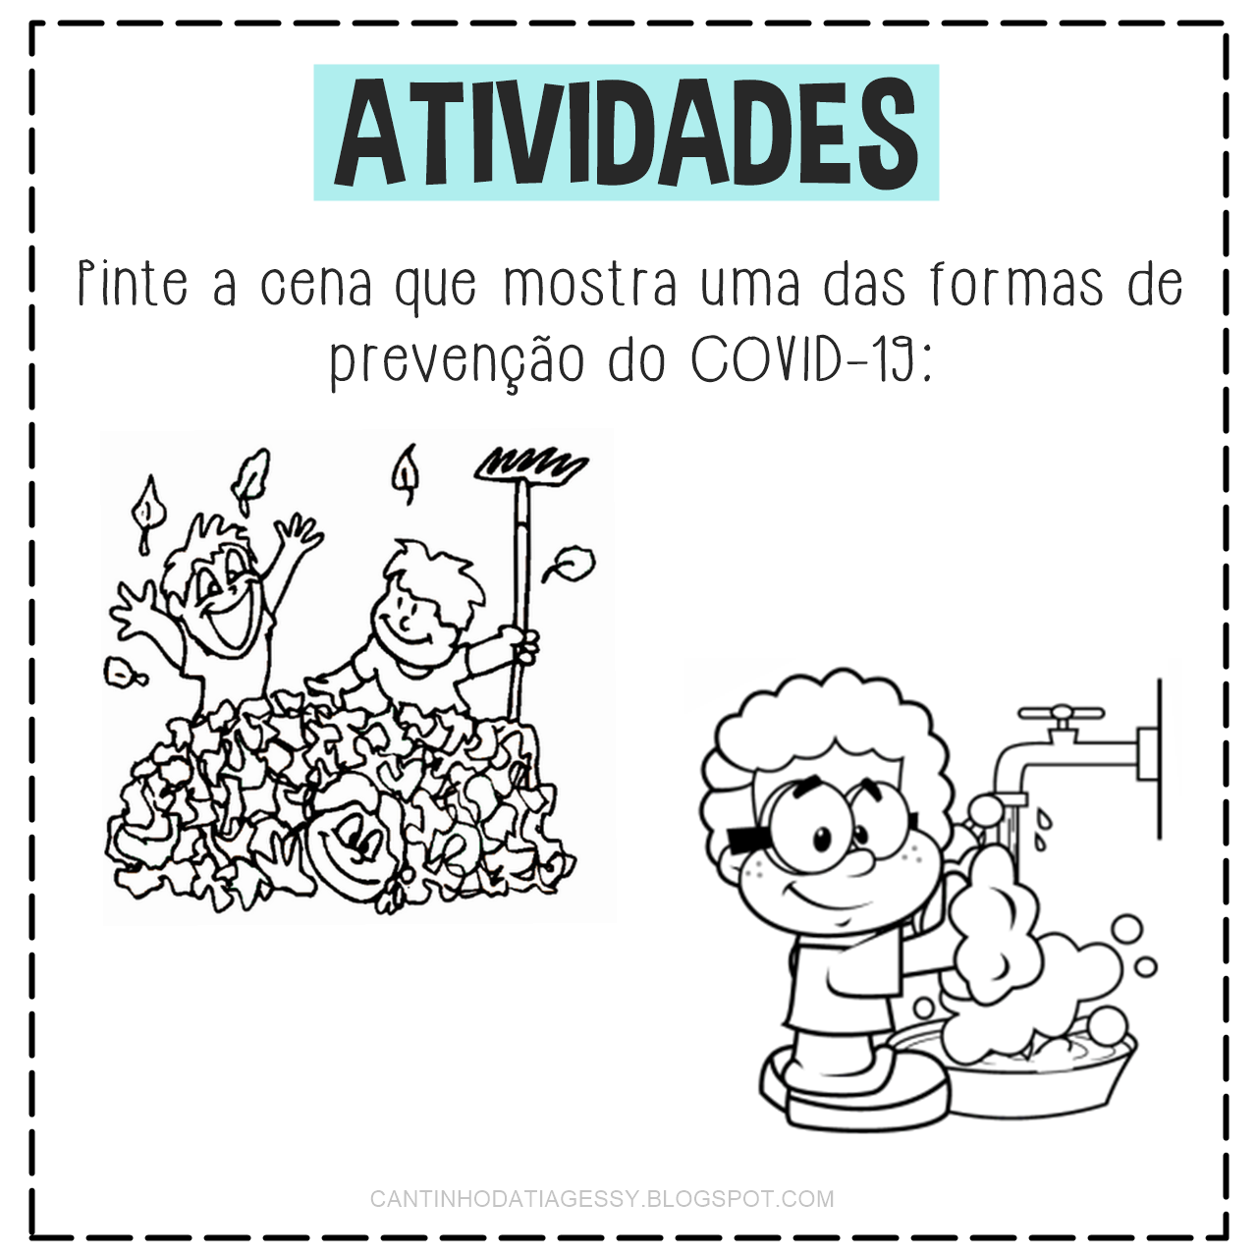
NOME: _______________________________________________________________________
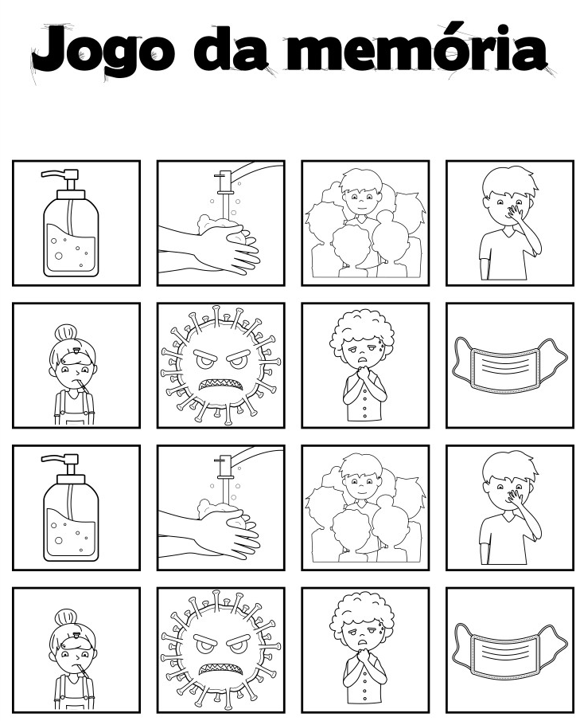
DATA: _____ / ____ / ______

